

Evaluation of Various Sensing Modalities for Accurate Measurement of Neck Flexion Angle during Thyroid and Ear Surgery

Group 8

Team Member: Zhen Hu, Hanqing Duan

Mentor: Dr. Russell Taylor, Dr. Deepa Galaiya

May 9th, 2020

Computer Integrated Surgery II

Dr. Russell Taylor

Spring 2020

Johns Hopkins University, Baltimore, MD

**1. Introduction**

**1.1 Surgical ergonomic**

Good posture is defined by the Posture Committee of the American Academy of Orthopedic Surgeons as “the state of muscular and skeletal balance which protects the supporting structures of the body against injury or progressive deformity, irrespective of the position (erect, lying, squatting, or stooping) in which these structures are working or resting”[1]. Correct upright posture is defined as when ears are aligned with the shoulders in the same line, leading to least strain on the back when in standing position[2].

The common neck-related syndromes are straight neck syndrome and forward head posture (FHP). Dangers of FHP can be described as a “DOMINO EFFECT” since one effect sets of a chain of similar events, leading to a cumulative result, i.e.,[3]

1. Head moves forward, thereby shifting the center of gravity.

2. As a primary compensatory mechanism, upper body drifts backward.

3. As a secondary compensation to upper body drift, both hips tilt forward.

Hence, FHP can not only cause neck pain but can also be a root cause of mid/lower back pain.

The purpose of this study is to analyze the surgeon’s neck posture while performing thyroid and ear surgery. Nowadays, there is more and more evidence suggesting that specific posture of surgeon while operating can contribute to discomfort, cervical musculoskeletal strain, and chronic pain. Postural neck pain can be caused by several factors. The persistent neck flexion, long periods of static posture, and the long time use of microscopes and magnifiers lead the microsurgeons in a particularly high risk to the pain mentioned above.

In this project, we are focusing on the surgeon posture during two kinds of surgeries: thyroid and ear surgery. As for both ear surgery and thyroid surgery, there are two kinds of surgical sceneries: traditional case and endoscopic case. When surgeons do ear surgery in a traditional way, as shown in **Figure 1**[4], they have to look through microscopes. For thyroid surgery, in a traditional way, as shown in **Figure 2**[5], surgeons have to stand over the patient. It is obvious that surgeons have to band their necks, and even sometimes they need to band over their bodies in order to finish specific operations. The persistent neck flexion is the main factor that causes the discomfort. However, as for endoscopic cases, as shown in **Figure 3**[6], surgeons can make full use of the monitors. It is easier for them to keep the correct upright posture for most of the time.

**Figure 1**. Ear Surgery(traditioanl case) **Figure 2.** Thyroid Surgery (tradtional case) **Figure 3**. Endoscopic Case

**1.2 The inertial measurement units (IMUs)**

Postural analysis has been extensively studied over the last decade, with many development methods gaining importance. In our project, we use two Inertial Measurement Units (IMUs) from LP-research company. The LP-Research Motion Sensor Bluetooth version 2 (LPMS-B2) series is a 9-axis Bluetooth IMU with three different MEMS sensors (3-axis gyroscope, 3-axis accelerometer, and 3-axis magnetometer).

The LPMS sensor calculates the orientation difference between a fixed sensor coordinate system (S) and a global reference coordinate system (G). Both coordinate systems are defined as right-handed Cartesian coordinate systems. The sensor coordinate system (S) is constructed as the following image (**Figure 4**[7]).

**Figure 4.** Sensor Coordinate System

The global reference coordinate system (G)can be divided into two different cases.

While the orientation calculation is using all acceleration, gyroscope, and magnetic data (G)system is defined as following:

* X positive when pointing to the magnetic north
* Y positive when pointing to the magnetic west
* Z positive when pointing up (gravity points vertically down with -1g)

While the orientation calculation is using only acceleration and gyroscope data, (G)system is defined as following:

* X positive aligned to ground plane horizontal projection of x axis of (S) when sensor powered on
* Y positive based on right-handed Cartesian coordinate definition
* Z positive when pointing up (gravity points vertically down with -1g)

The data recorded from the IMUs includes sensor number, timestamp, 3-axis acceleration values, 3-axis gyroscope degrees, and 3-axis magnetic field strengths. Our aim is to derive the pitch angles from the difference between two IMUs, so the 3-axis Euler angles (Euler X, Euler Y and Euler Z) and the 4-axis quaternion data (QuatW, QuatX, QuatY, QuatZ) are our interests.

**2. Significance**

Poor surgical ergonomics may lead to surgeon disability. A recent survey of plastic surgeons in the United States, Canada, and Norway showed that nearly two-third of respondents reported four neck discomfort related to their occupation[8]. Among surveyed laparoscopic, ophthalmic, and general surgeons, the reported prevalence of musculoskeletal symptoms in the neck and shoulders is as high as 87%[9]. It is crucial and meaningful for us to investigate the region of the neck flexion angle which the surgeon feels comfortable while operating.

The neck flexion angle data can also be used to correct the new surgeons’ posture, preventing them from chronic injury again. What’s more, the data may help to show whether the endoscopic surgery have more advantages than the traditional surgery by comparison.

**3. Technical Approach**

In this part, the process of neck flexion angle calculation and analysis are elaborated. **Figure 5** shows the whole workflow. Firstly, set up software and environment for data collection, which will be further discussed in part 3.1. Then, before collecting data, both IMUs should be calibrated against Electromagnetic tracker (EM tracker), which will be specific explained in part 3.2. Next, in part 3.3, the mathematical model of how to obtain accurate neck flexion angle from data collected by IMUs will be derived in detail. Finally, the method of analyzing neck flexion angle changes in different scenarios will be delineated.

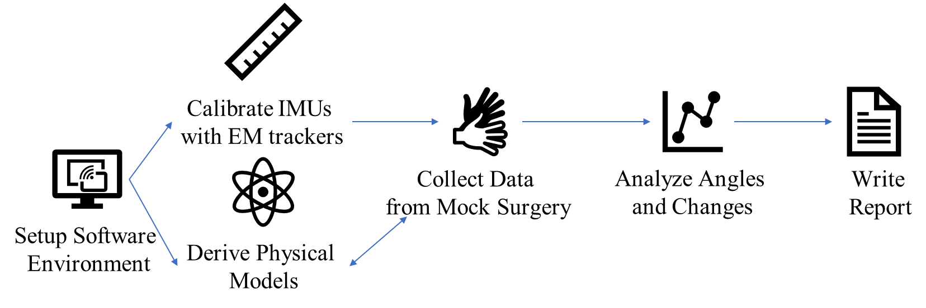

**Figure 5**. Project Workflow Overview

**3.1 Software environment setup**

When calibrating, ROS (Robot Operating System) in Linux is used for data collection. Three packages, ‘lpms-lib’, ‘lpms_imu’, ‘timesync’, should be installed. All software and environment initialize steps are documented in the ‘Documentation of environment set up’ file uploaded on both Wiki page and Github (https://github.com/huzhen965278384/Computer-Intergrated-Surgery-II-Course).

Other procedures, like data collection during surgeries, and analysis for both calibration data and surgical data, we use MATLAB in Windows system. All data collection steps are documented in the ‘How To Use IMU’ file uploaded on both Wiki page and Github.

**3.2 IMU calibration**

One IMU has three sensors – gyroscope, accelerometer, and magnetometer. Each type of sensors measures angle and acceleration in all the X, Y, and Z axis. However, these sensors may also measure noise and drift, due to increasing thermal, aging, vibration, impact. So, it is necessary to correct measurement values for IMU before using it. In this project, EM tracker is treated as the ground truth system.

**Figure 6** shows the prototype of the calibration system. One IMU and one EM tracker are stitched at the same plane of a laptop stand, so they could change the same angle simultaneously when the laptop stand rotates. There are 9 different angles that the laptop stand could stand at, so for each specific angle, data from both IMU and EM tracker are collected for a while in order to keep the data stable and eliminate the noise.

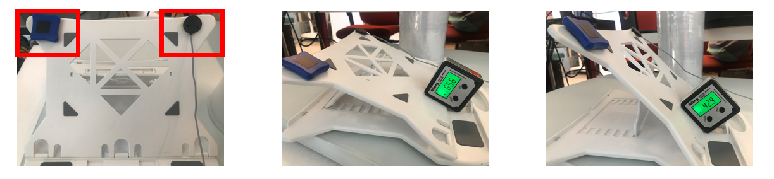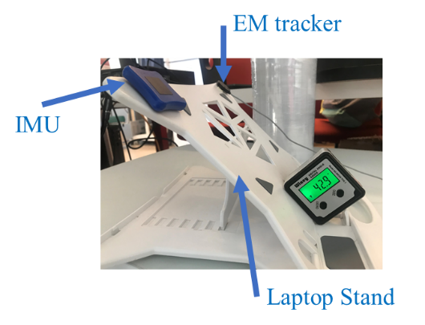

**Figure** **6**. Prototype of the Calibration System

In this project, the neck flexion angle, corresponding to the pitch angle in IMU coordinate system (shown in **Figure 7**) is what we care about. Therefore, we only need to calibrate the pitch angle for IMU. In our calibration prototype, when the laptop stand rotates, only the pitch angle of the IMU and EM tracker will change. So, calibrating the total angle in this prototype is calibrating the pitch angle for the IMU. The raw angle data collected from both IMU and EM tracker is represented by quaternions. These 9 different angles are separated into two groups, reference () and samples (other angles).

**Figure** **7**. IMU’s Coordinate System

Then the calibrating process should follow these steps.

Firstly, average quaternions of IMUs and EM tracker for each angle in order to remove the influence of noise.

Secondly, based on the following formula, calculate angles of 8 samples data corresponding to the reference for IMU and EM tracker respectively:

where is the reference quaternion, and is one of the 8 different averaged quaternions samples. (Note: every quaternion is [w, x, y, z])

Now, 8*3 angles are obtained (8 samples, and 3 equipment- two IMU and one EM tracker). The final step is using one IMU’ 8 angles and the EM tracker’s 8 angles to do linear regression. The angle from IMU is treated as the input of the linear regression system, and the angle from the EM tracker is treated as the reference of the linear regression system. After a linear regression function is obtained, the calibrated pitch angle could be obtained by inputting any pitch angle measured by IMU into the linear regression function.

Above all, the whole process is the IMU pitch angle calibration.

**3.3 Neck flexion angle model**

When surgeon stands, there is a natural neck flexion angle. When his/her starts operating, the neck flexion angle changes. The definition of the neck flexion angle in this project is the variation of the pitch angle between IMUs when a surgeon changes his/her posture from standing to operating. So, the Euler angles data of both IMUs should be collected for both the reference posture (standing normally and quietly for more than one minute) and the operating posture. Note that, all Euler angles are with sequence XYZ. Then the neck flexion angle could be derived by following steps shown in the workflow (**Figure 8**).

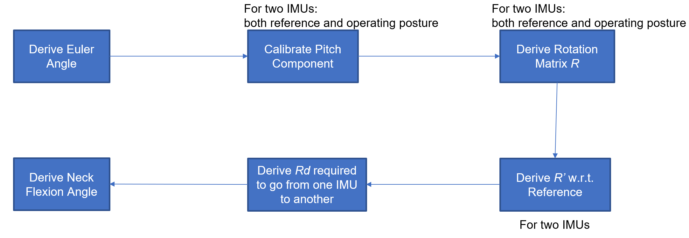

**Figure 8**. Neck Flexion Angle Model Workflow

Firstly, based on the calibrated linear regression function obtained in part 3.2, calibrate all Euler angles’ pitch component for both reference and operating postures and both IMUs.

Secondly, transfer all calibrated XYZ sequence Euler angles to quaternions using *eul2quat* function in MATLAB and average the quaternions for the reference posture for two IMUs respectively to get two reference quaternions.

Thirdly, transfer all quaternions to rotation matrix based on the following formula.

where

Fourthly, calculate rotation matrix for operating posture with respect to their reference for both IMUs separately based on the following formula.

where are rotation matrix for operating posture for two IMUs, and are rotation matrix for reference for two IMUs.

Fifthly, calculate difference rotation matrix between two rotation matrices calculated above based on the following formula.

Finally, transfer the difference rotation matrix to Euler angle based on the following formula. The pitch angle component of the Euler angle is the neck flexion angle we want.

**4. Data Analysis Result & Conclusion**

The neck flexion angle we obtained is with time sequence and the sample frequency is 100 Hz. Two things in this project we care about are the change of the neck flexion angle verse time and the distribution (histogram) of the neck flexion angle in the whole operating. Then, for different surgery scenarios, we’d like to analyze how these two things are different.

**4.1 IMU calibration results**

Based on the calibration method in part 3.2, the linear regression of both IMUs are shown in **Figure 9**. From the mean square error (MSE), 0.1501 degree for IMU-A6, and 0.1409 degree for IMU-1A, we could say these linear regression functions are acceptable. Also, the R-square for both IMUs are both near to 1 (0.9997), indicating the regression effect is good enough. So, the final calibration function for these two IMUs are the following equations:

**where the units are degree.**

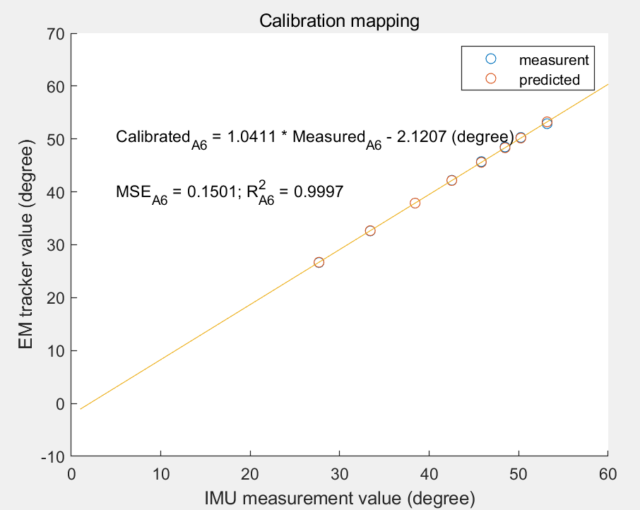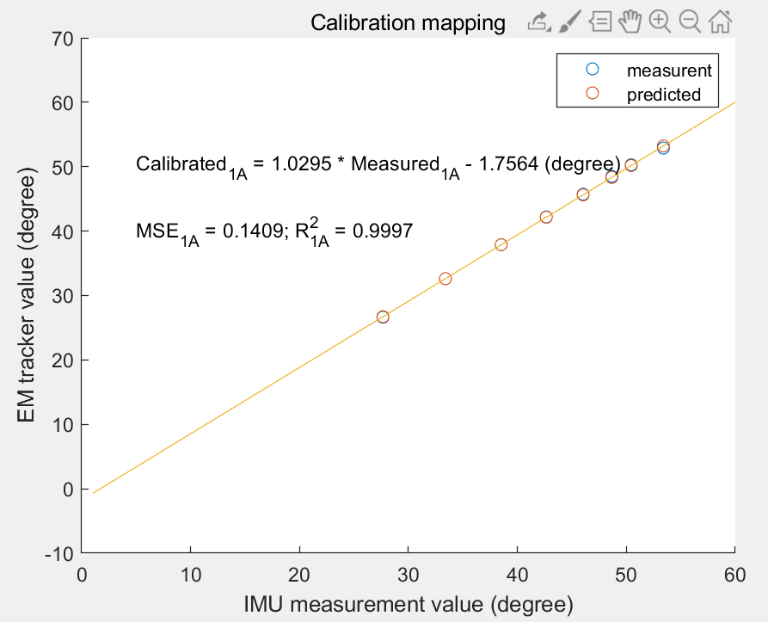

**Figure 9**. IMU Calibration Results

**4.2 Mock OR data: basic head movement**

We firstly collect data in seven different scenarios. In each scenario, the surgeon is asked to do head movement which is frequently used while operating.

All left figures in **Figure 10** to **Figure 16** show how the three Euler Angles change with time. (Note: the definitions of pitch angle, yaw angle, and roll angle are the same as the IMU’s coordinate system defined in **Figure 7**.)

All left figures in **Figure 10** to **Figure 16** are the histograms of three Euler angles, which show the distribution of neck flexion angle during the procedure.

**A. Turn head up and down periodically**

**Figure 10**. Turn Head Up and Down Result

The pitch angle changes between -80° to 80° strongly and periodically, which is reasonable.

Yaw angle and roll angle change a little in the region of (-10° to 10°).

**B. Rotate head to left shoulder around Z axis periodically**

**Figure 11**. Rotate Head to Left Shoulder around Z axis Result

Roll angle changes between 0° to 80° degree periodically, which is reasonable.

Pitch angle and Yaw angle change little in the range of (-10°, 10°).

**C. Rotate head to right shoulder around Z axis periodically**

**Figure 12**. Rotate Head to Right Shoulder around Z axis Result

Roll angle changes between -80° to 20° periodically, which is reasonable.

Pitch angle and Yaw angle change little in the range of (-10°, 10°).

There is no significant difference between left and right circumstances.

**D. Turn head to left side periodically**

**Figure 13**. Turn Head to Left side Result

Yaw angle changes between -10° to 45° periodically, which is reasonable.

Pitch angle and Roll angle change little.

**E. Turn head to right side**

**Figure 14**. Turn Head to Right side Result

Yaw angle changes between -60° to 5° periodically, which is reasonable.

Pitch angle and Roll angle change little.

There is no significant difference between left and right circumstances.

**F.** **Rotate head in all direction**

**Figure 15**. Rotate Head in all Direction Result

Pitch angle and Yaw angle change periodically. Roll angle changes randomly.

**G. Shake shoulder**

**Figure 16.** Shake Shoulder Result

Pitch, yaw and roll angles change little and randomly (almost zero), which shows that shaking shoulder will not affect the accuracy of neck flexion angles.

**4.3 Mock OR data: surgical situation**

In this part, we will compare neck flexion angle in two different surgical scenarios mentioned in part 1. One is the traditional case, and the other is the endoscopic case. All data are collected with the help of Dr. Deepa in mock OR.

**A. Traditional case**

**Figure 17**. Traditional Case Result

Neck flexion angle (Pitch angle) keeps at 75° to 100° for a long time.

Mean of neck flexion angle: 74.9309 °.

Standard deviation of neck flexion angle: 74.9309 °.

**B.** **Endoscopic case**

**Figure 18**. Endoscopic Case Result

Neck flexion angle (Pitch angle) keeps at 25° to 35° for a long time.

Mean of neck flexion angle: 32.1144°.

Standard deviation of neck flexion angle: 6.6778°.

The permutation test has been used to test the hypothesis that whether the distribution of the two surgical scenarios are the same or not. The p-value is 6.6805e-5, which is really small, showing that they are significant different.

The red dash lines in **Figure 17** and **Figure 18** are located at 50 degree. This is a threshold for trapezius pressure, which will be further discussed in the Conclusion part.

**4.4 Measurement at home: ergonomics position data**

The original plan is to collect and compare the real surgical data from different surgeons in various surgical scenarios. However, due to the COVID-19, the elective surgeries were all cancelled. IMUs would not connect in the dissection lab, so Dr. Deepa collected some mock data on herself tying at home as different ergonomic positions data.

**A. Sitting at soft desk chair, typing**

**Figure 19**. Sitting at Soft Desk Chair, Typing Result

Pitch angle concentrates on 0°, which is reasonable because sitting on sofa desk chair do not require bending the neck a lot.

Yaw angle concentrates on 10°.

Roll angle changes in a large range.

**B. Walking and typing with computer in hands**

**Figure 20**. Walking and Typing with Computer in Hands Result

Pitch Angle changes in (-50°, 30°), which is also reasonable because typing in computer requires eyes to look down.

Roll Angle changes in (100°, 150°).

Yaw Angle concentrates in (0°, 30°).

**C.** **Slouching in bed, typing**

**Figure 21**. Slouching in Bed, Typing Result

Pitch Angle almost concentrates on -20°. It is reasonable to have a negative pitch angle when slouching in bed because the pillow will lift the neck, resulting the difference angle between the IMU in back and IMU in head is negative.

Yaw Angle almost concentrates on -40°.

Roll Angle changes in the (40°, 65°).

**5. Conclusion**

In a series by Lee, muscle fatigue levels of the right and left upper trapezius is the highest when neck flexion angle is at 50° and the lowest at 30°[10]. In traditional case, neck flexion angle is above 50° for a long time, implying that muscle fatigue level of trapezius is high. Compared with endoscopic case, the neck flexion angle is near 30° for most time, implying that the risk of back pain is lower. It is obviously that the usage of endoscope will be beneficial for surgeons by avoiding the abnormal neck posture comparing to the traditional surgery case.

To avoid excessive consistent pressure on the neck, we suggest surgeon changing the posture regularly for at least 10s and further recommend surgeons to actively perform neck strengthening exercises on a daily basis, which will decrease the effect of FHP on surgeon’s neck.

**6. Future Improvement**

As for the data collection part, it is a pity that we did not collect the clinical data in operating room this semester. Hope we could have a chance to make up this pity in the future.

For data analysis part, our analysis seems very simple and straightforward because the mock OR data have some limitation. Due to the limiting collection time, it is impossible for us to distinguish different phases of a surgery. Surgeons will perform different tasks during a whole surgery, which implies that the neck flexion angles will have enormous changes. So, if the chance to collect data in real OR is given, it is a good idea to divide the whole surgery into different phases and compare the mean and SD of each phase. For example, as illustrated in this paper[11], a normal spine surgery can be divided into five different phases: exposure, fixation, decompression, fusion, and closure. Decompression and fusion are the most stressful phases affecting surgeon’s neck. After calculating the p-value, the neck flexion angles are found to be significantly higher during decompression and fusion when compared with exposure and closure.

Except the biggest neck flexion angle, the mean and SD of the angle, we are also interested in the time region. If surgeons keep bending his/her neck in a big angle for a long time, it will definitely hurt the neck. Finding the maximum time that surgeons can endure is also necessary. It is hard for us to do such data analysis from our Mock OR data because we only record for 1 minute. However, it usually takes four hours to perform an ear surgery or a thyroid surgery.

Designing a wearable warning system can also be considered as a research direction in the future. When the neck flexion angle exceeds a certain value or surgeon keeps in a big neck flexion angle status for a long time, the system can remind the surgeon to adjust the position promptly.

**7. Management Summary**

Zhen Hu and Hanqing Duan are equally distributed to this project.

Hanqing Duan is responsible for IMU Calibration, documentation of environment setup and documentation of calibration.

Zhen Hu is responsible for neck flexion angle derivation, documentation of angle derivation, documentation of code.

We worked together on writing project proposal, analyzing the Mock OR Data and ergonomics data, writing final report.

**8. Deliverables**

**Minimum:**

* + Calibration result of two IMUs separately against EM tracker
  + Documentation of software setting and calibration steps

**Expected:**

* + Calibration result of two IMUs separately against EM tracker
  + Documentation of software setting and calibration steps

**Maximum:**

* + Data analysis report of all possible scenarios.
  + Final report

**9. What we learned**

This project leads us to a new world because we have never touched any angle calculation before. We thoroughly learned the Euler angle calculation and the usage of quaternion. Besides that, how to overcome difficulties is another important lesson. For example, when doing the calibration, we are struggling with the Bluetooth connection for a long time. The IMUs cannot connect stably when the EM tracker is connected at the same time. We only spent a half hour to collect the calibration data, but it took almost three hours to figure out the reason and solution before collecting. Maintaining a positive attitude and being persistent are necessary in all researches.

For management, it is beneficial for us to learn how to propose a detailed and thoughtful plan and divide a heavy workload into weeks at the beginning of a research. We never thought about we should come up with a backup plan ahead of time. Otherwise all schedules would be postponed if emergency happens. COVID-19 period is a tough time for everyone. We luckily adjusted our schedule and finished this project on time.

Learning how to give an elevator pitch in one minute and perform a good presentation is also valuable for us.

**10. Acknowledgments**

We would like to thank our mentors Dr. Russell Taylor and Dr. Deepa Galaiya for reviewing our work in weekly Galen group meeting and providing us with their guidance throughout the project period. We also appreciate Anton Deguet a lot for helping us setup the computer environment at the beginning.

**11. Reference**

[1] Grimmer-Somers K, Milanese S, Louw Q. Measurement of cervical posture in the sagittal plane. J Manipulative Physiol Ther 2008;31:509-17.

[2] Straus EW. The Upright Posture. In: Natanson M. (eds) Essays in Phenomenology. Springer, Dordrecht. 1966. doi: doi.org/10.1007/978-94-017-5403-3_10.

[3] Naresh-Babu, J et al. “Surgeon's Neck Posture during Spine Surgeries: “The Unrecognised Potential Occupational Hazard”.” Indian journal of orthopaedics vol. 53,6 (2019): 758-762. doi:10.4103/ortho.IJOrtho_677_18

[4] Khansa I, Khansa L, Westvik TS, Ahmad J, Lista F, Janis JE. Work‐related musculoskeletal injuries in plastic surgeons in the United States, Canada, and Norway. Plast Reconstr Surg. 2018;141(1):165e‐175e.

[5] Capone AC, Parikh PM, Gatti ME, Davidson BJ, Davison SP. Occupational injury in plastic surgeons. Plast Reconstr Surg. 2010;125(5):1555‐1561.

[6] Lee S, Lee D, Park J. Effect of the cervical flexion angle during smart phone use on muscle fatigue of the cervical erector spinae and upper trapezius. J Phys Ther Sci 2015;27:1847-9.

[7] Yan, Xuzhong, et al. “Wearable IMU-based real-time motion warning system for construction workers' musculoskeletal disorders prevention.” Automation in Construction 74 (2017): 2-11.

[8] Versteyhe, Mark, et al. “A Novel Method to Estimate the Full Knee Joint Kinematics Using Low Cost IMU Sensors for Easy to Implement Low Cost Diagnostics.” Sensors 20.6 (2020): 1683.

[9] Lobo D, Anuarbe P, López-Higuera JM, Viera J, Castillo N, Megía R. Estimation of surgeons' ergonomic dynamics with a structured light system during endoscopic surgery. Int Forum Allergy Rhinol. 2019;9(8):857–864. doi:10.1002/alr.22353

[10] A tutorial on Euler angles and Quaternions -- http://www.weizmann.ac.il/sci-tea/benari/

**[11] LPMS-B2 Series Hardware Manual ver. 1.0 -- https://lp-research.com/wp-content/uploads/2020/03/20200310LpmsB2HardwareManual.pdf**

1. Grimmer-Somers K, Milanese S, Louw Q. Measurement of cervical posture in the sagittal plane. J Manipulative Physiol Ther 2008;31:509-17.
2. Straus EW. The Upright Posture. In: Natanson M. (eds) Essays in Phenomenology. Springer, Dordrecht. 1966. doi: doi.org/10.1007/978-94-017-5403-3_10.
3. Naresh-Babu, J et al. “Surgeon's Neck Posture during Spine Surgeries: “The Unrecognised Potential Occupational Hazard”.” Indian journal of orthopaedics vol. 53,6 (2019): 758-762. doi:10.4103/ortho.IJOrtho_677_18
4. https://oklahoman.com/gallery/articleid/3808606/
5. http://amandeepmedicity.org/specialities/bariatric-metabolic-surgery
6. http://www.tristonekidneyhospital.com/index.html
7. https://lp-research.com/wp-content/uploads/2020/03/20200310LpmsB2HardwareManual.pdf
8. Khansa I, Khansa L, Westvik TS, Ahmad J, Lista F, Janis JE. Work‐related musculoskeletal injuries in plastic surgeons in the United States, Canada, and Norway. Plast Reconstr Surg. 2018;141(1):165e‐175e.
9. Capone AC, Parikh PM, Gatti ME, Davidson BJ, Davison SP. Occupational injury in plastic surgeons. Plast Reconstr Surg. 2010;125(5):1555‐1561.
10. Lee S, Lee D, Park J. Effect of the cervical flexion angle during smart phone use on muscle fatigue of the cervical erector spinae and upper trapezius. J Phys Ther Sci 2015;27:1847-9.
11. Naresh-Babu, J et al. “Surgeon's Neck Posture during Spine Surgeries: “The Unrecognised Potential Occupational Hazard”.” Indian journal of orthopaedics vol. 53,6 (2019): 758-762. doi:10.4103/ortho.IJOrtho_677_18.